**Typing Game (not actual name) Wire Frames**

**CSC 667 – Internet Application and Development**

## **Fall 2017**

**Term Project**

### Team L Members

Norald Alejo

JianHong Kuang

Nhan Nguyen

Mrinalini Garre

### Github

<https://github.com/sfsu-csc-667-fall-2017/term-project-csc667-project-jianhong-nhan-norald>

Table of Contents

Default landing page 3

Logged in page / User profile 4

Gameplay 5 - 9

Top scores 10

Chatroom 11

Authentication 12 - 14

Default Landing Page

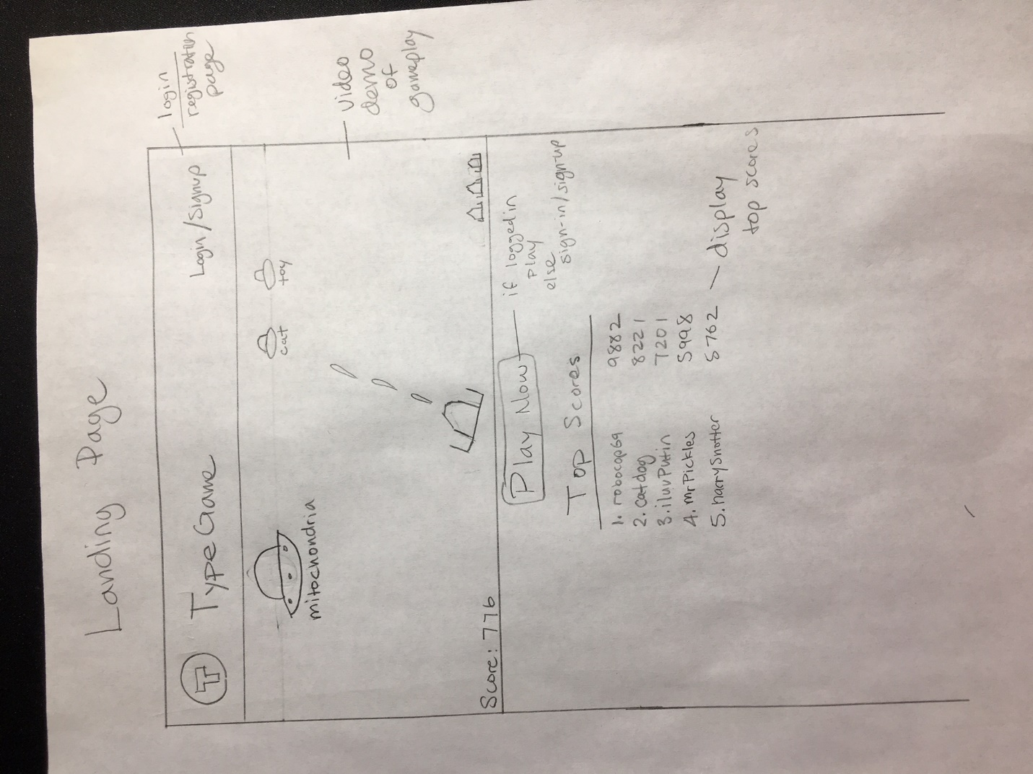

* Asks user to sign in if not logged in
* Allows user to see top scores and also video demo of gameplay
* Default/Logged In Page with User Profile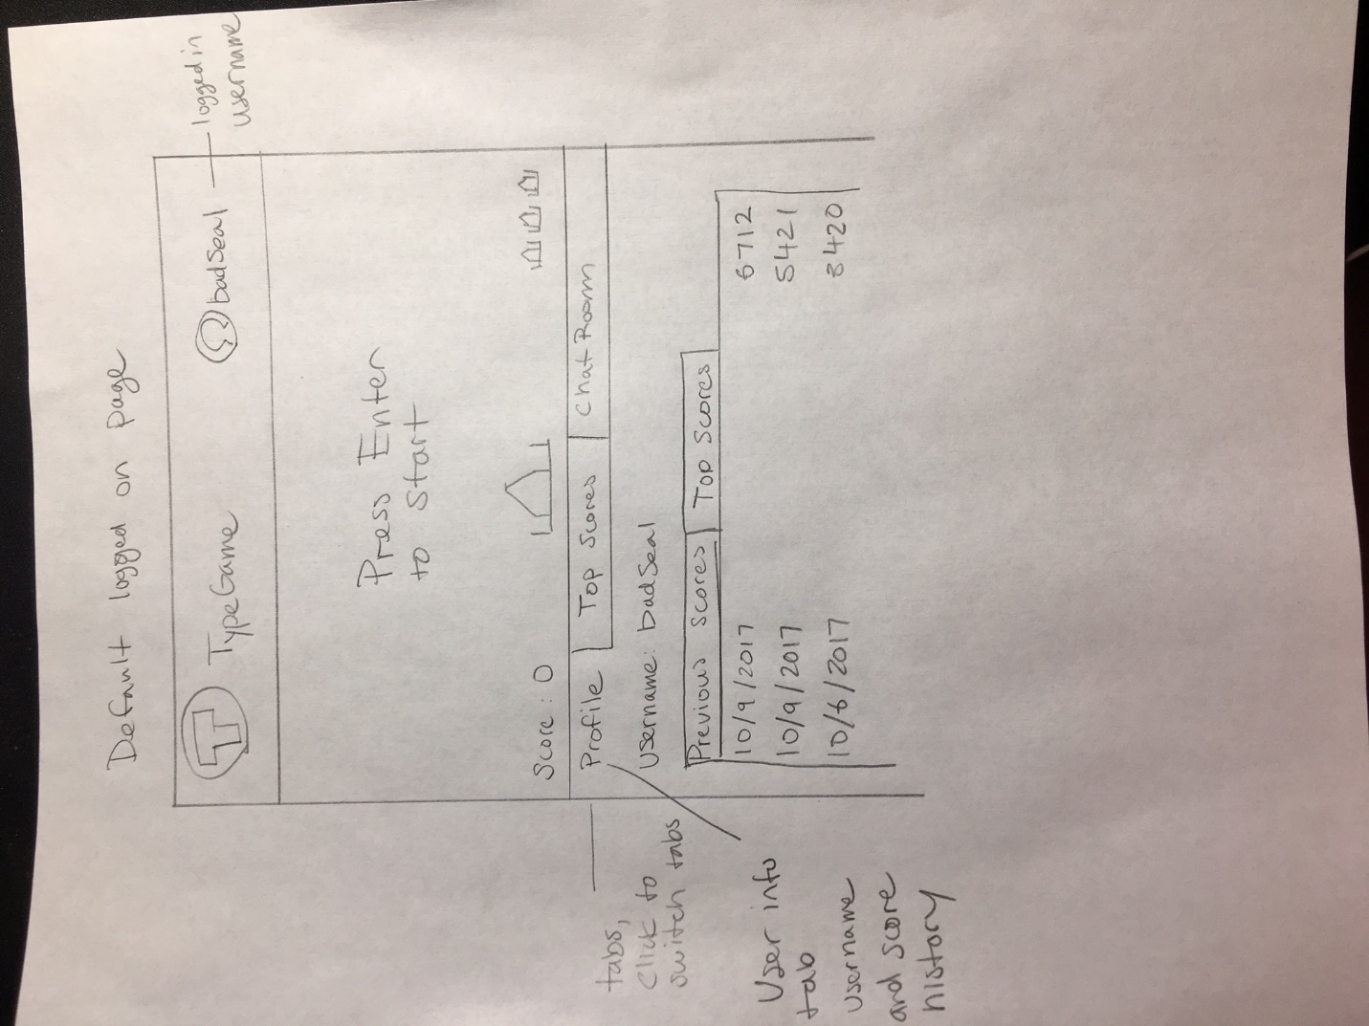
* Profile will display User’s username and past scores

Gameplay

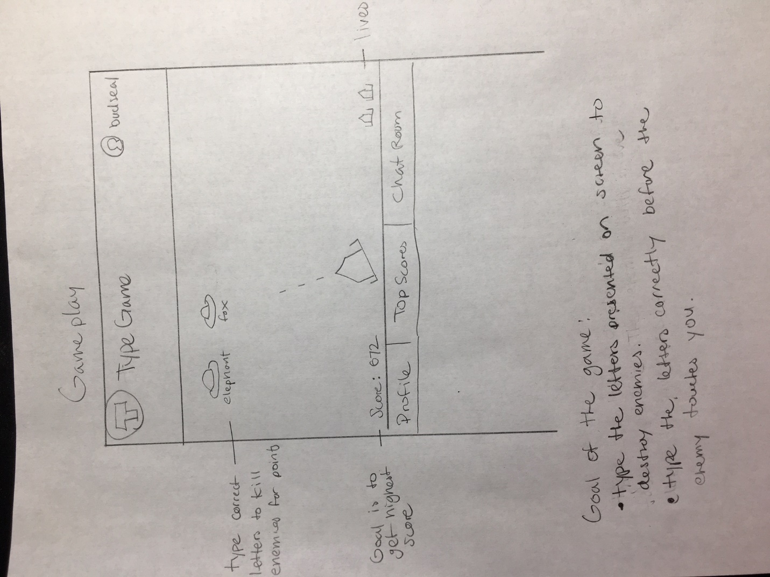

* Enemies will show up with letters underneath them
* Type the words correctly to destroy enemies
* Type as much words as possible before the enemies touch you

#### How to win

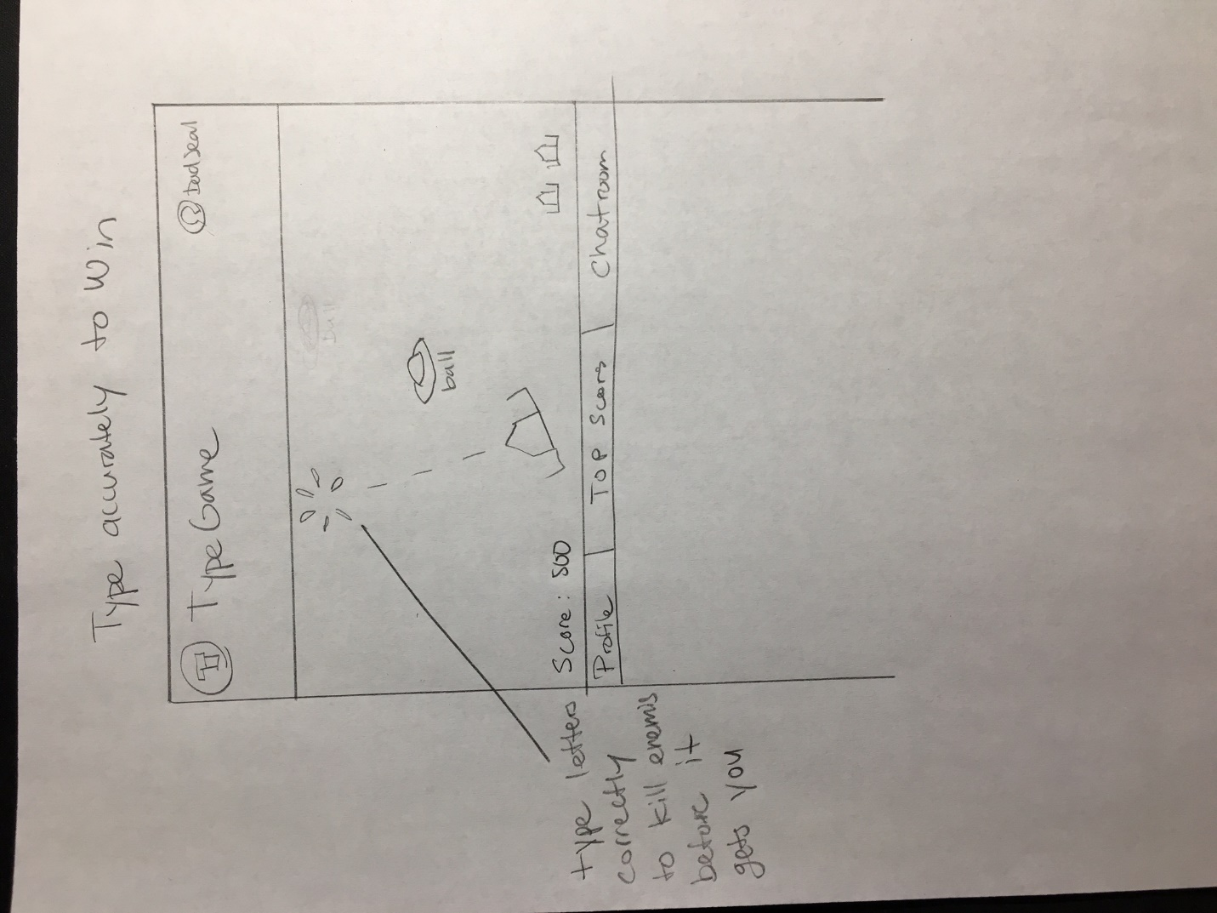

* Type as many words accurately as possible to destroy enemies and accumulate points.

##### Losing

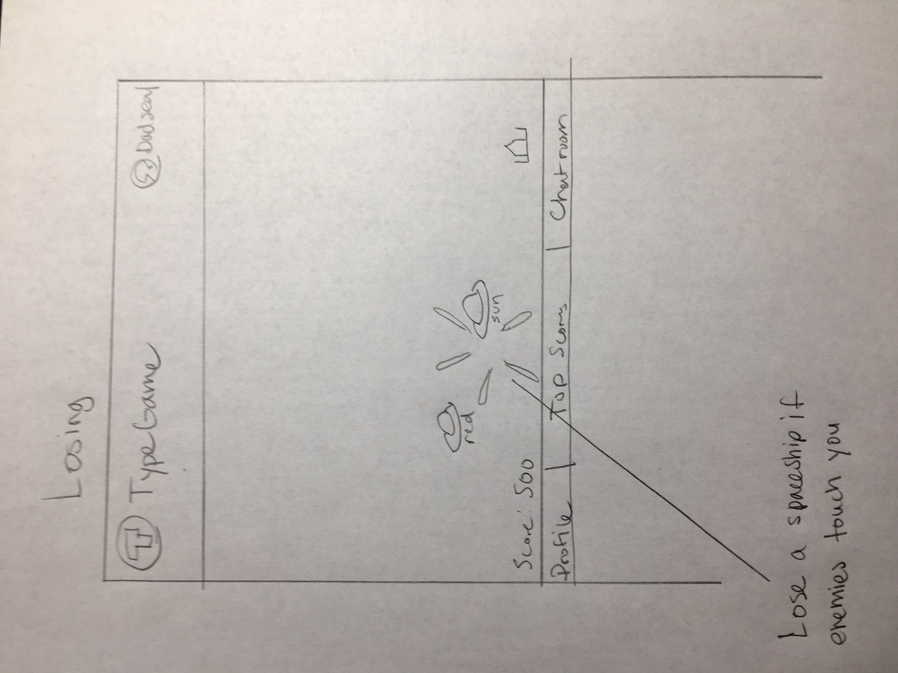

* If enemies touch your spaceship, your spaceship will explode

Game Over

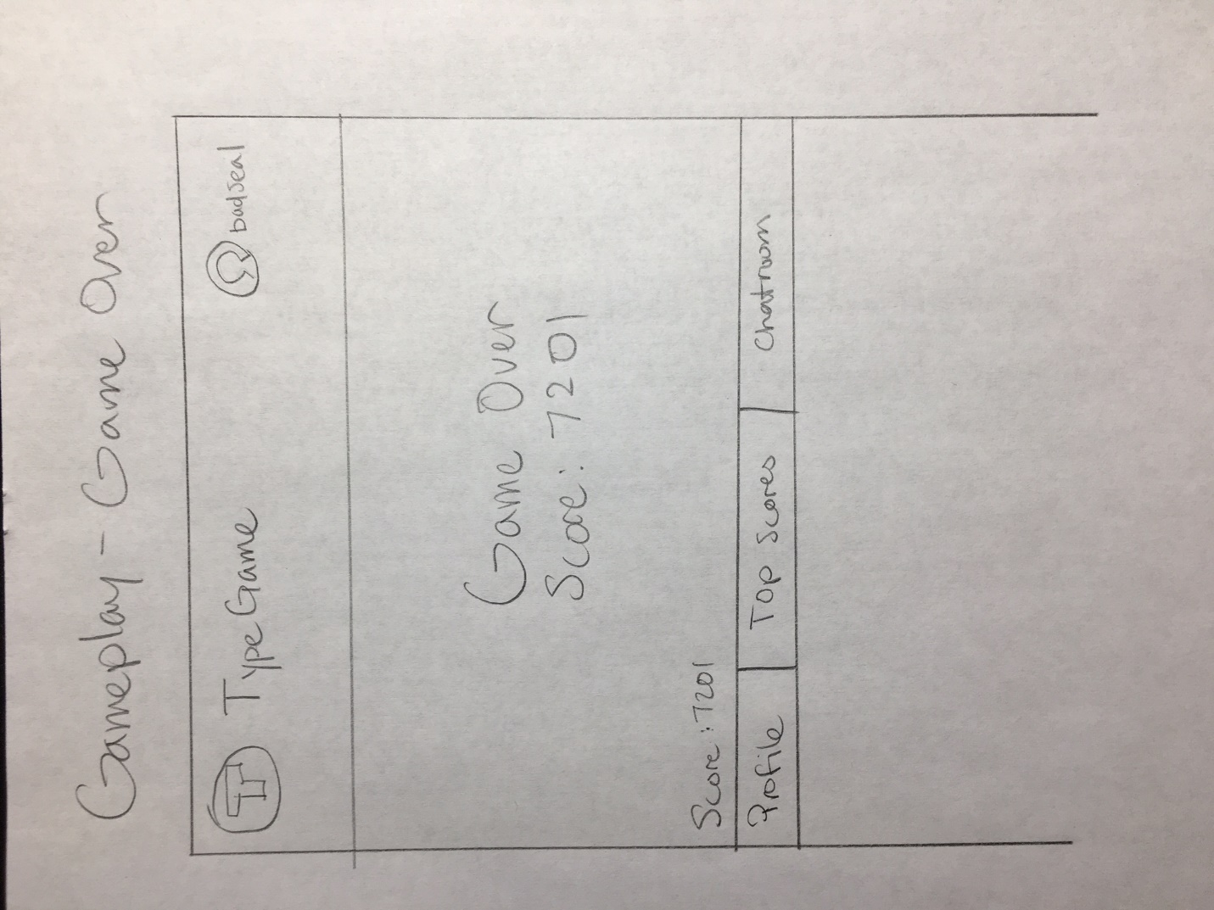

* Lose all spaceships and the game is over

Game Paused

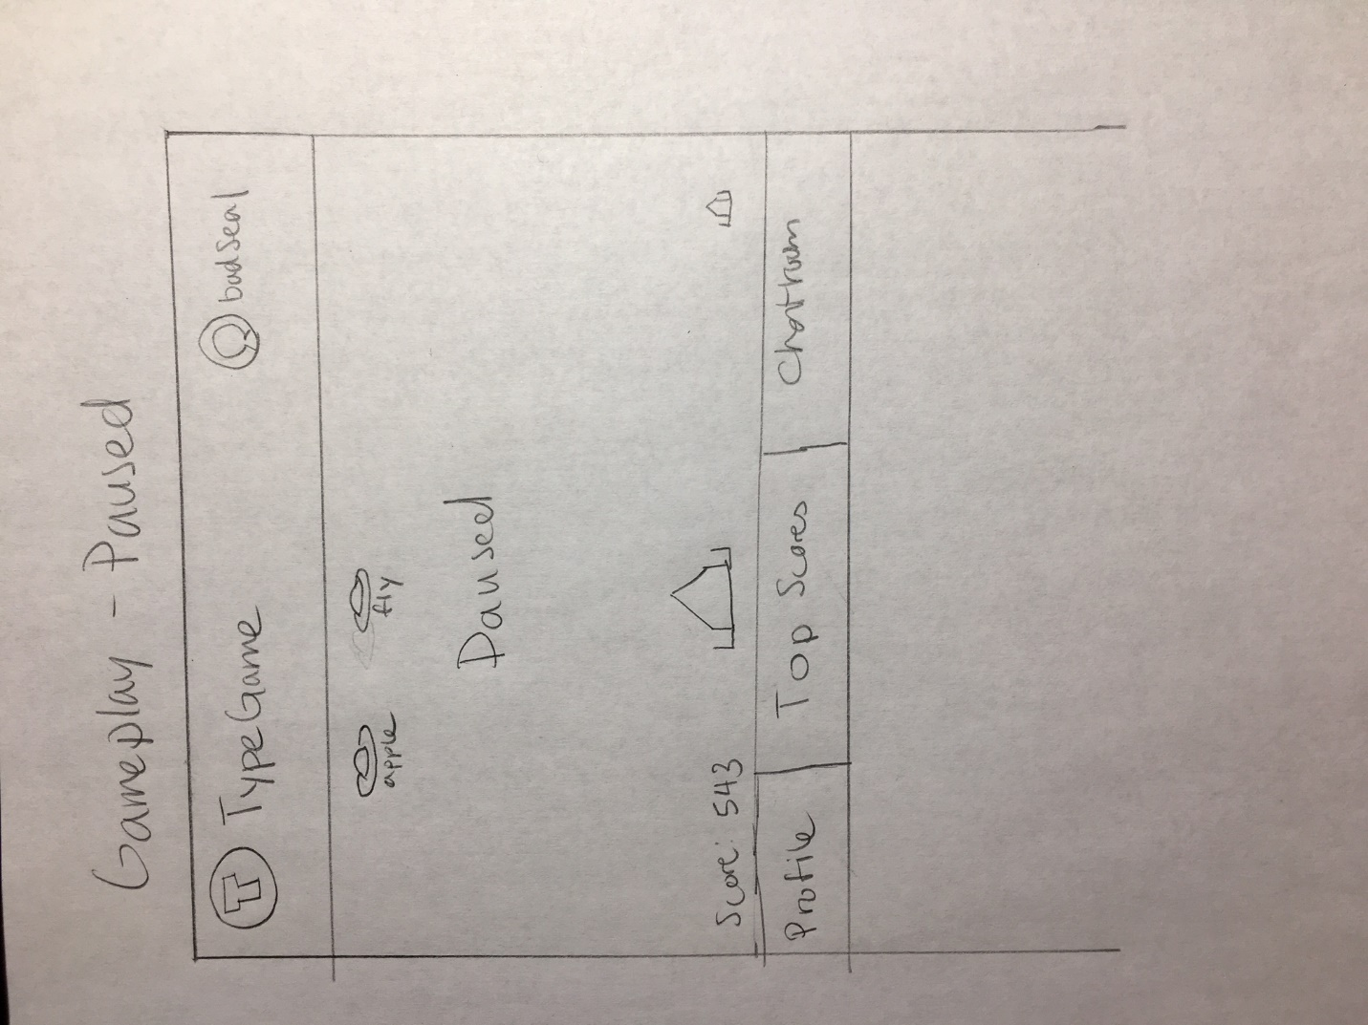

* Game paused in case players need a timeout

Top Scores

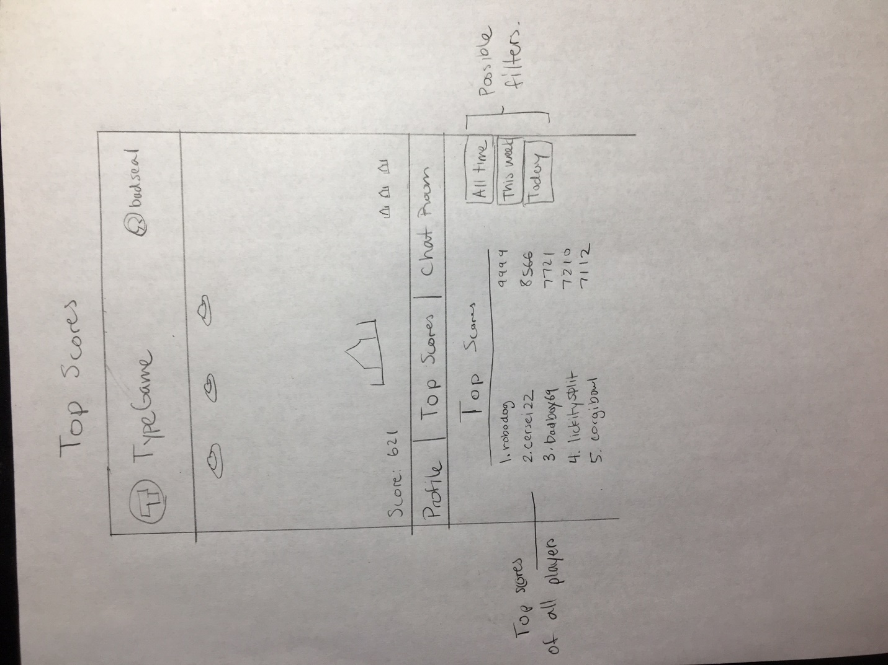

* Top Scores Tab
* Will list the top scores of all players

##### Chatroom

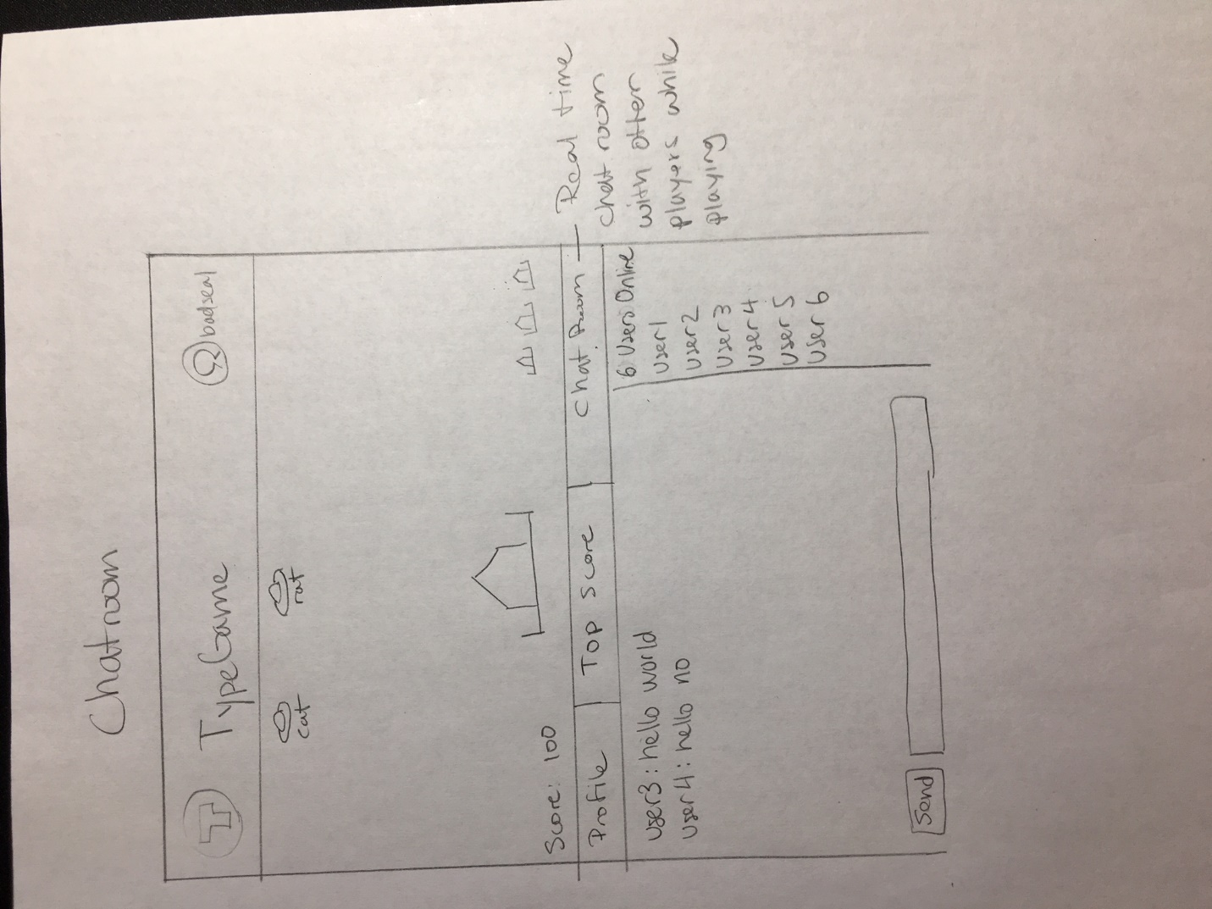

* Real Time Chatroom while playing game

Log In

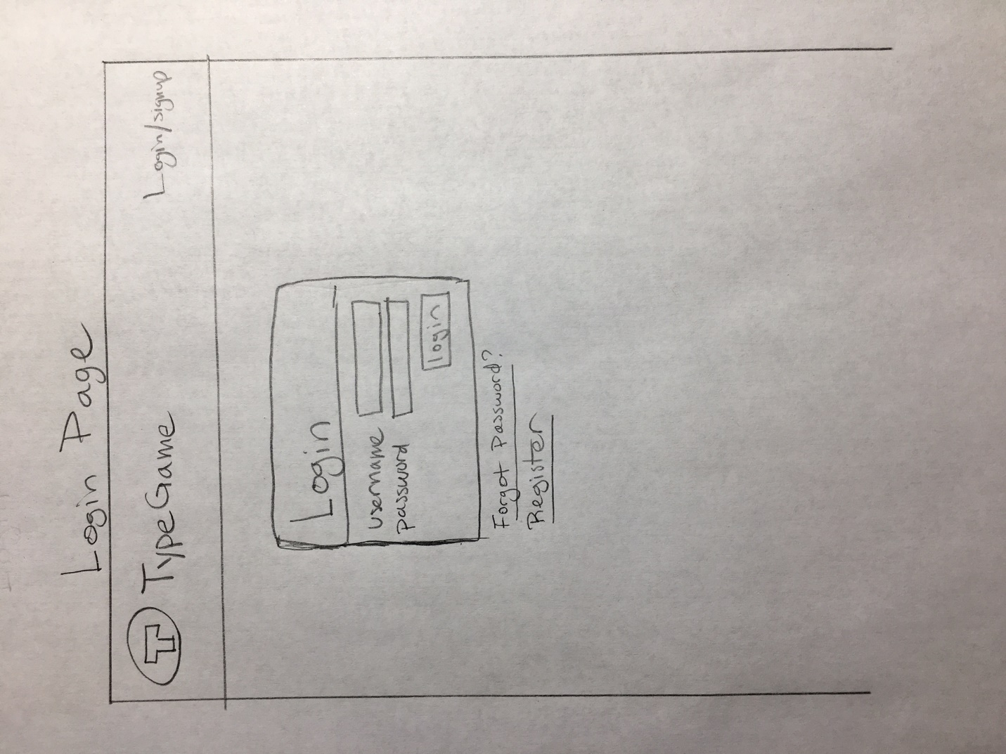

* Users are able to login to their created account. This is required
* Users are able to register an account to play the game
* Users are able to reset password if they forget their password

Register

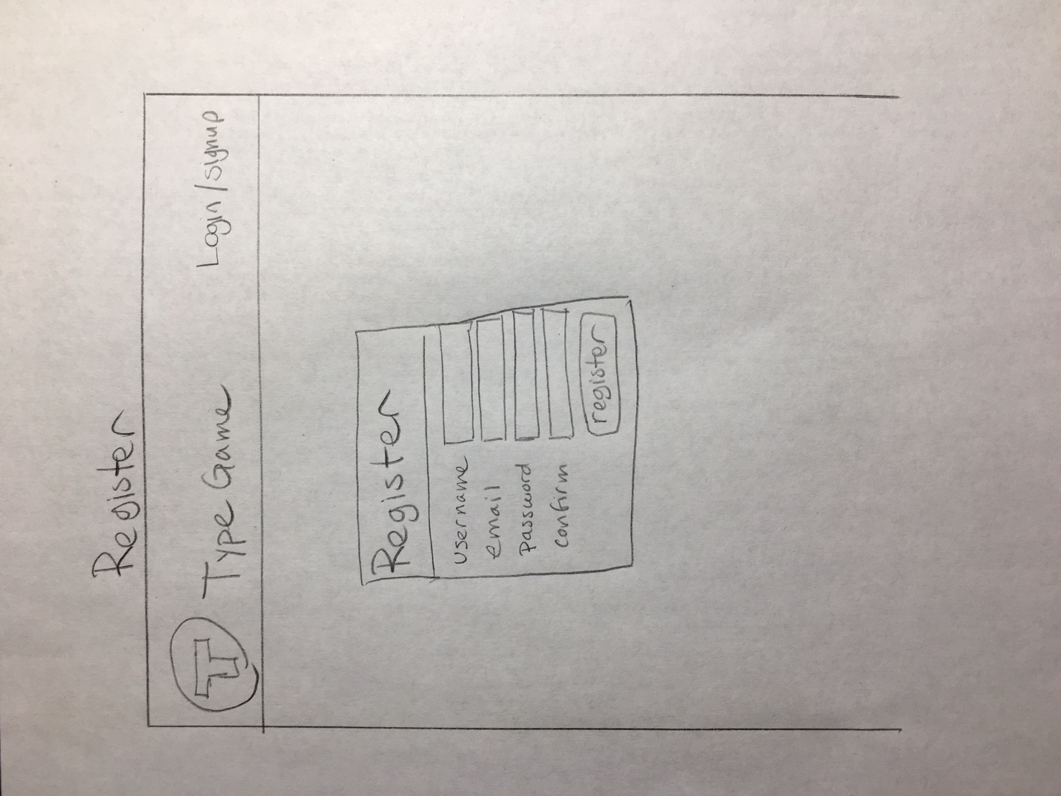

* Users are able to create an account using their email by filling the boxes. They are also can create their own passwords

Forgot Password

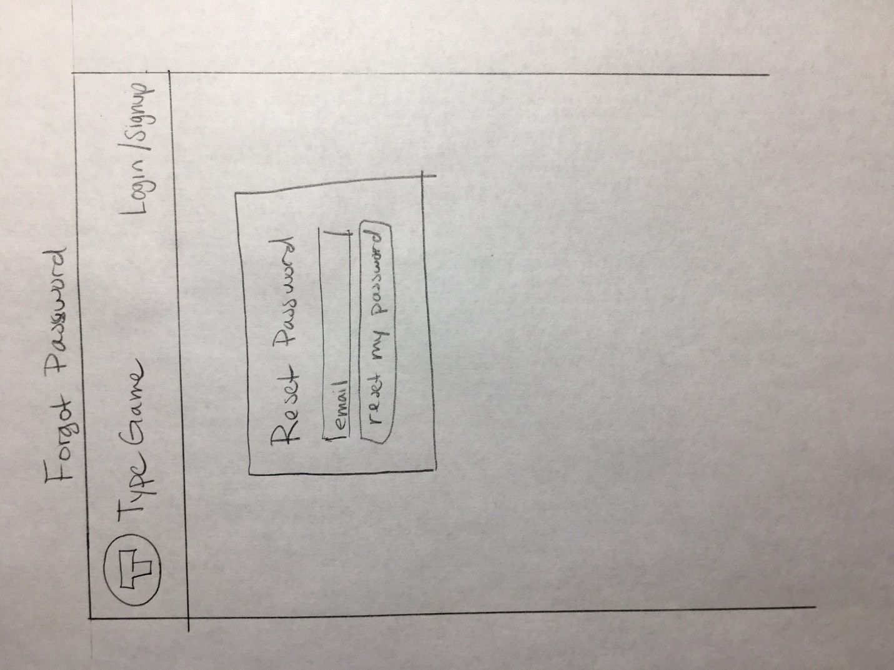

* Users are able to reset password by inputting their email. Server will then send an email to create an password reset link.